PROJECT INTERCOMPUTE: INDIVIDUAL RESEARCH CONTRIBUTION
Specialized Technical Dossier — Pavan Meka (Registration No: 12317192)
Student Researcher: Pavan Meka (Reg: 12317192) | Architectural Specialization: Network Modeling & Fault Injection | Consensus Integration Specialist
Core Codebase Modules: network_fault_injector.py, worker.py, PAPER.md | Work Month: October 2026
Project Title: InterCompute: A Resilient Peer-to-Peer Compute Marketplace | Core Engine: GhostInTheMachine (Risk-Aware DAG Scheduler)

1. Executive Technical Summary & Individual Research Scope
Individual Contribution: My individual research contribution focused on modeling the physical realities of consumer access links and stochastic node churn in decentralized edge computing. I engineered network_fault_injector.py and worker.py, formulated the mathematical transmission bottleneck equations for residential networks (Uk << Dk), built the discrete-event Poisson hazard and Weibull fatigue churn injectors, and investigated architectural integration pathways for Proof of Stake (PoS) consensus mechanisms in decentralized validation.
2. Capstone Project Vision: InterCompute vs. Existing Products (Vast.ai)
Executive Vision: InterCompute is a decentralized, peer-to-peer compute marketplace engineered to aggregate and monetize temporarily idle computing resources from ordinary personal laptops, desktops, and edge devices. Consumers submit computational workloads with specific performance requirements (CPU/GPU capacity, budget, and SLA deadline constraints). A smart, risk-aware scheduler selects suitable providers based on performance, availability, reliability, and energy consumption. Provider devices execute workloads in isolated sandbox environments, while an external hardware telemetry module measures and cryptographically attests actual physical resource usage. Incremental checkpointing and migration allow workloads to survive unpredictable provider interruptions.
2.1 Existing Market Benchmark: The Vast.ai Model
Vast.ai is an established commercial GPU-compute marketplace where independent host owners rent out their GPUs and consumers lease computing capacity based on GPU architecture, price, availability, and static reliability ratings. However, Vast.ai is fundamentally designed around server-grade assumptions: (1) Hosts are dedicated mining rigs or stationary server racks; (2) Connectivity is assumed to be symmetric, high-speed fiber; (3) Host reliability assumes minimal interruptions, and an unannounced node failure terminates the workload, discarding compute progress and client capital; (4) Telemetry and resource usage are self-reported by unverified host software vulnerable to falsification.
2.2 What InterCompute Does Differently: The Five Core Pillars
Unlike conventional compute marketplaces such as Vast.ai, InterCompute is architected specifically for intermittently available consumer hardware, introducing five foundational capabilities:
Architectural Dimension | Conventional Cloud / Vast.ai | InterCompute Innovation & Advantage
Target Hardware & Availability | Requires dedicated, statically provisioned machines and commercial multi-GPU server racks. | Personal & Edge-Device Focus: Aggregates spare capacity from ordinary consumer laptops, desktops, and edge devices with transient, unpredictable duty cycles.
Device Owner Priority | Host machine is fully leased to renter. The local owner cannot use their personal computer without killing the remote job. | Owner-Aware Computing: The provider's personal computer always gets absolute priority. Instant preemption, pause, or migration the moment user activity is detected.
Trust & Metric Integrity | Software-only self-reporting. Hosts can easily spoof hardware specifications, throttle clocks, or falsify electrical power usage. | Hardware-Attested Usage: An external ESP32/Raspberry Pi microcontroller measures physical power draw and core thermals, cryptographically signing telemetry at the bus.
Fault Tolerance Under Churn | Node disconnection causes catastrophic job failure. Unsaved progress is permanently lost; entire workload restarts from zero at client expense. | Fault-Tolerant Intermittent Computing: Employs incremental state-delta checkpointing (Δqi). Surviving replacement peers resume execution in ~5.3s.
Network Modeling | Assumes high symmetric bandwidth. Communication grinds to a halt on consumer residential broadband. | Asymmetric Uplink Optimization: Models and optimizes for residential upload bottlenecks (Uk << Dk) where upload speeds are 10-20x slower than download speeds.
Scheduling Intelligence | Simple price and static benchmark matching. Blind to preemption hazard rates, session wear-out, and thermal fatigue. | Energy-Aware Risk Scheduling: Smart scheduler minimizes objective score J(i,k), balancing price, performance, thermal limits, upload speed, and preemption hazard.

3. Residential Bandwidth Physics & Stochastic Churn Injection
When parent task i on worker k transfers payload dij to child task j on worker l, traditional cluster schedulers assume symmetric links. In residential broadband, effective throughput is strictly bounded by the sender's uplink: b_kl = min(U_k, D_l) approx U_k. I implemented the Discrete-Event Fault & Transmission Simulation Engine:
ALGORITHM: DiscreteEventFaultAndNetworkInjector(Workflow DAG G, NodePool K, SimulationClock T)
Input: Scheduled DAG G with task locations loc(i), Uplink rates U_k, Hazard rates lambda_k
Output: Exact event log of transmission delays, preemption crashes, and recovery latencies

1: For each dependency edge (i, j) in E do
2: If loc(i) != loc(j) then
3: EffectiveBandwidth <- min(U_{loc(i)}, D_{loc(j)}) // Uplink bottleneck
4: TransferDuration <- (d_ij * 8.0) / EffectiveBandwidth + NetworkLatency(loc(i), loc(j))
5: ScheduleEvent(Event='PAYLOAD_ARRIVED', Time = T_finish[i] + TransferDuration)
6: End If
7: End For
8: // Stochastic Node Preemption Simulation Loop
9: For each active worker k executing task i do
10: Draw uniform random variable u ~ Uniform(0, 1)
11: TimeStepFailureProb <- 1.0 - exp(-lambda_k * (Δt / 3600.0))
12: If u < TimeStepFailureProb then
13: // Inject Worker Preemption Crash
14: LogEvent(Type='NODE_CRASH', Worker=k, Task=i, Time=T.current)
15: ComputeLost <- T.current - LastCheckpointTime(i)
16: ReplacementWorker <- DiscoverSurvivingPeer(K, Requirements=c_i)
17: RecoveryDelay <- (Δq_i * 8.0) / min(U_store, D_{ReplacementWorker}) + T_restore
18: ScheduleEvent(Event='TASK_RESUMED', Worker=ReplacementWorker, Time=T.current + RecoveryDelay)
19: End If
20: End For

4. Asymmetric Bandwidth Regression Analysis
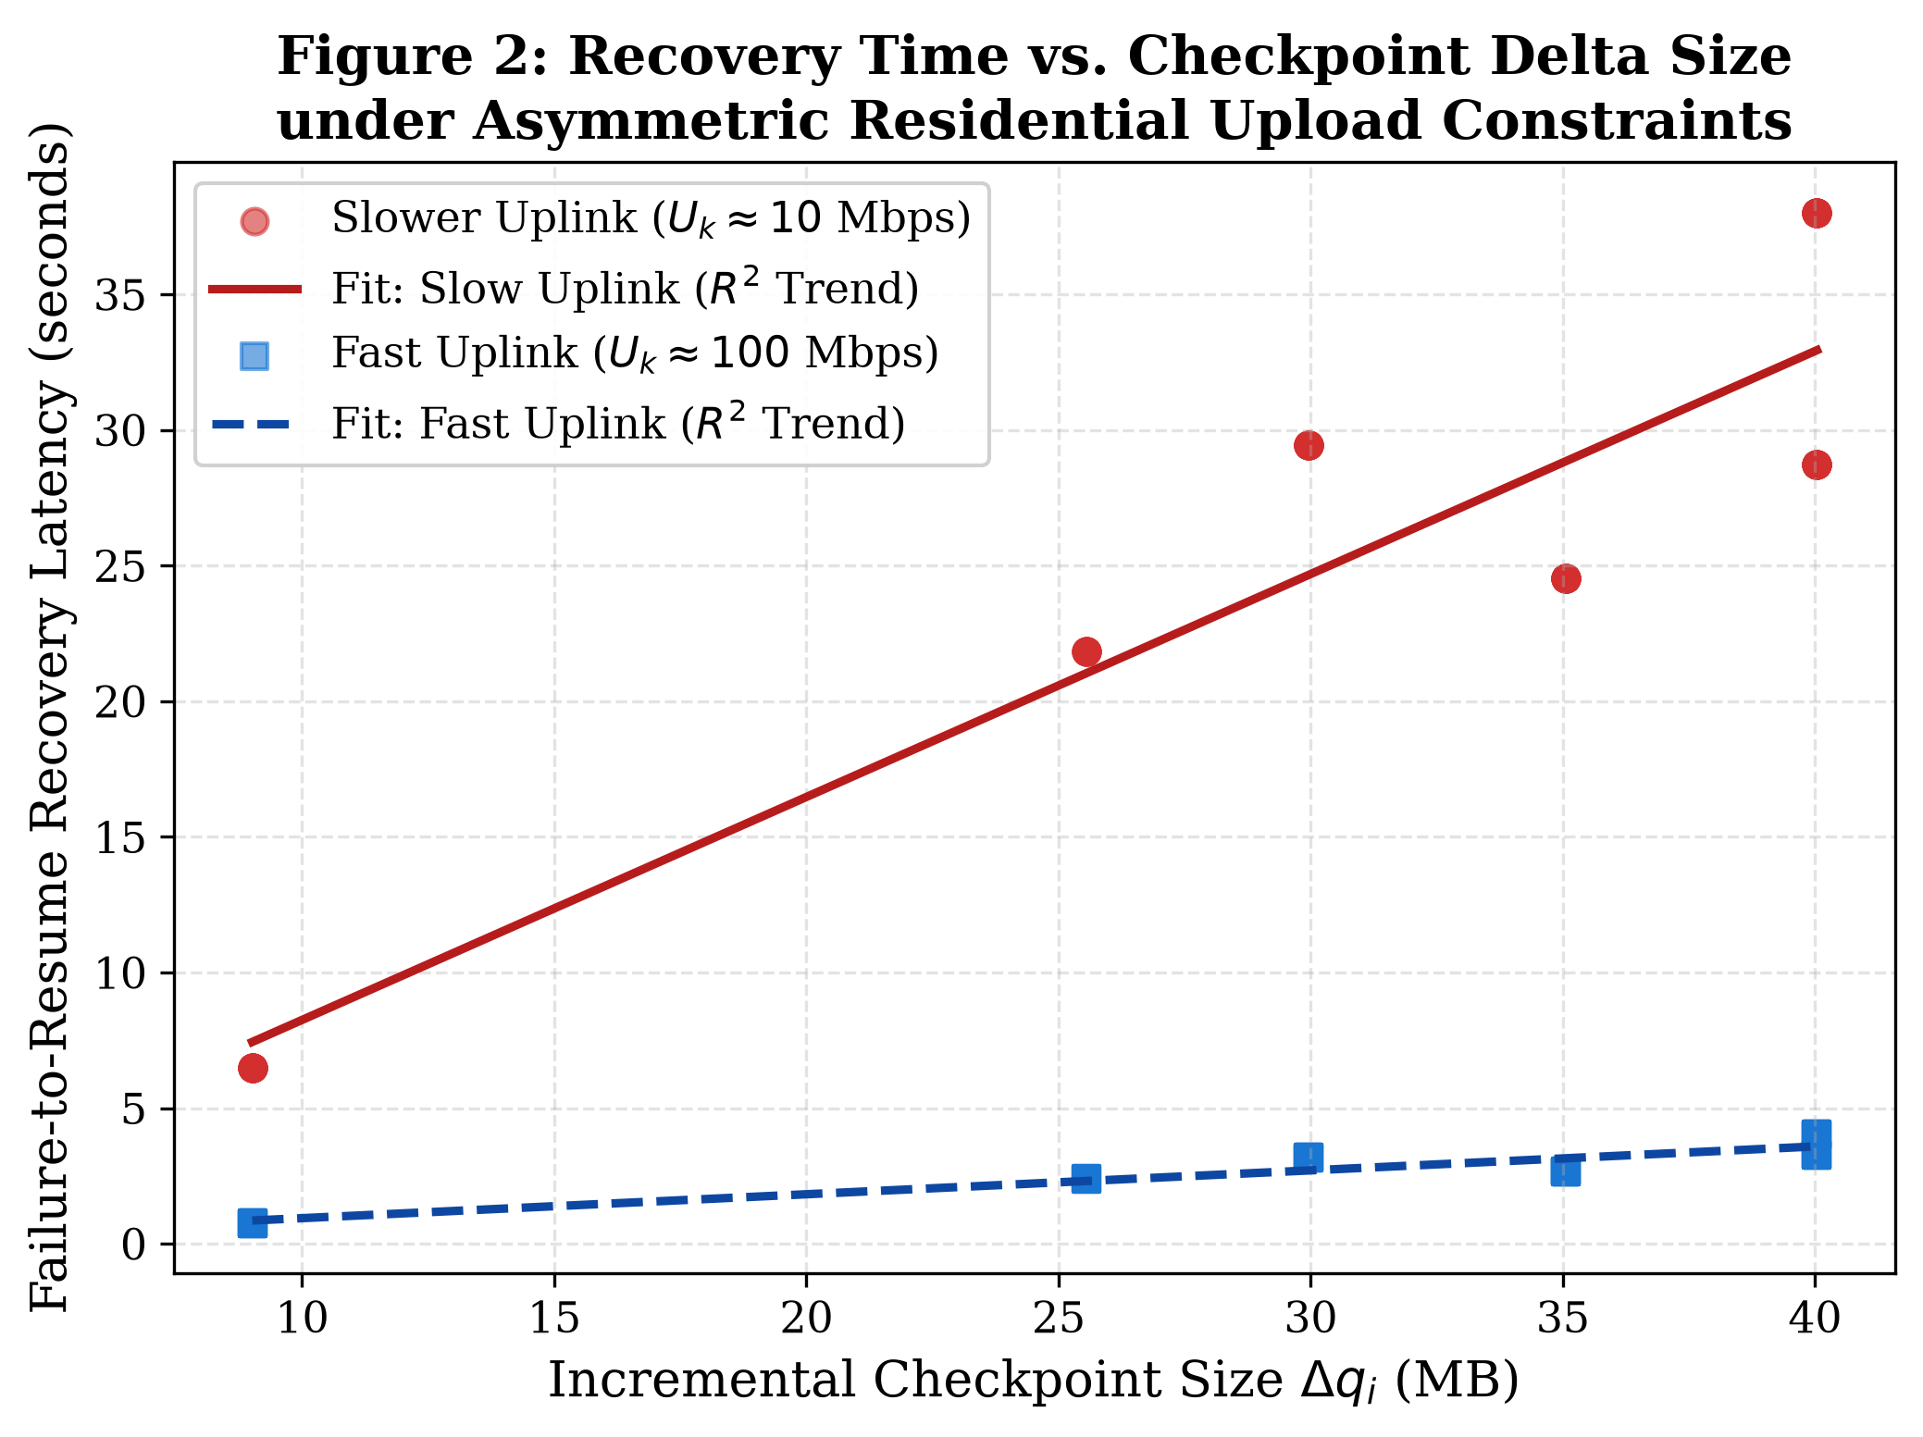
Figure 1: State Recovery Latency vs. Checkpoint Delta Size under Asymmetric Residential Uplinks (10 vs 100 Mbps).
5. Proof-of-Stake (PoS) Consensus & Decentralized Validation Pathways
As part of my contributions to PAPER.md, I investigated decentralized validation mechanisms. In a commercial P2P marketplace, validators must confirm that task checkpoints and computations actually occurred without trusting any single entity. I formulated a Proof-of-Stake (PoS) validation layer where validators stake tokens to sign checkpoint attestations. Malicious validators or cheating compute nodes face automatic slashing penalties, ensuring economic security across consumer pools.

